5: Event Registration Form - Zoho Creator Reports Suite
Aim:
To design and build a complete suite of reports in Zoho Creator for the "Event Registration Form" application, demonstrating the use of all nine report types available in Zoho Creator.
Reports Used Overview
Report Type | Report Name
List View | Event_Registration_Report
Spreadsheet View | Event_Registrations_Spreadsheet
Kanban View | Registration_Status_Kanban
Calendar View | Event_Schedule_Calendar
Map View | Participant_Location_Map
Timeline View | Registration_Activity_Timeline
Pivot Table | Event_By_Category_Pivot
Chart View | Event_Registration_Chart
Summary View | Event_Wise_Summary

Detailed Report Descriptions

Event_Registration_Report (List View)
- Purpose: Acts as the main report for the event coordinator, displaying all participant registrations in a clean, searchable tabular format.
- Features: Includes search, sorting, and filters for participant name, email address, contact number, event name, registration date, and registration status.

Event_Registrations_Spreadsheet (Spreadsheet View)
- Purpose: Helps event coordinators review and update registration details quickly in a grid layout.
- Features: Supports quick editing of selected fields such as registration status, payment status, and attendance while keeping essential participant details consistent.

Registration_Status_Kanban (Kanban View)
- Purpose: Provides a visual workflow for tracking registrations through stages such as Registered, Confirmed, Attended, and Cancelled.
- Features: Registration cards can be organized by status to make it easier to monitor and manage participant progress.

Event_Schedule_Calendar (Calendar View)
- Purpose: Helps coordinators view upcoming events and manage event dates, schedules, and registration-related activities.
- Features: Monthly, weekly, and daily views make event dates and scheduled activities easy to identify.

Participant_Location_Map (Map View)
- Purpose: Displays the geographical distribution of participants when location or address details are collected in the registration form.
- Features: Map pins can help coordinators understand participant locations and plan event logistics, where location data is available.

Registration_Activity_Timeline (Timeline View)
- Purpose: Helps coordinators track registration activity over time and review when participants submit their forms.
- Features: Presents registration records chronologically to help identify periods of high registration activity.

Event_By_Category_Pivot (Pivot Table)
- Purpose: Summarizes registrations by event name and event category to compare participation across different events.
- Features: Displays grouped counts and totals for quick comparison of event registrations.

Event_Registration_Chart (Chart View)
- Purpose: Visually compares registration counts across events, categories, or registration statuses.
- Features: Charts and filters help coordinators identify popular events and monitor registration trends.

Event_Wise_Summary (Summary View)
- Purpose: Provides a concise summary of registrations for each event to support planning and coordination.
- Features: Displays grouped registration counts and relevant totals for a quick overview of participant information.
Screenshots:
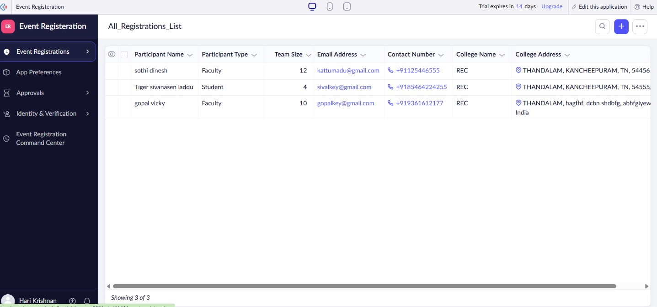

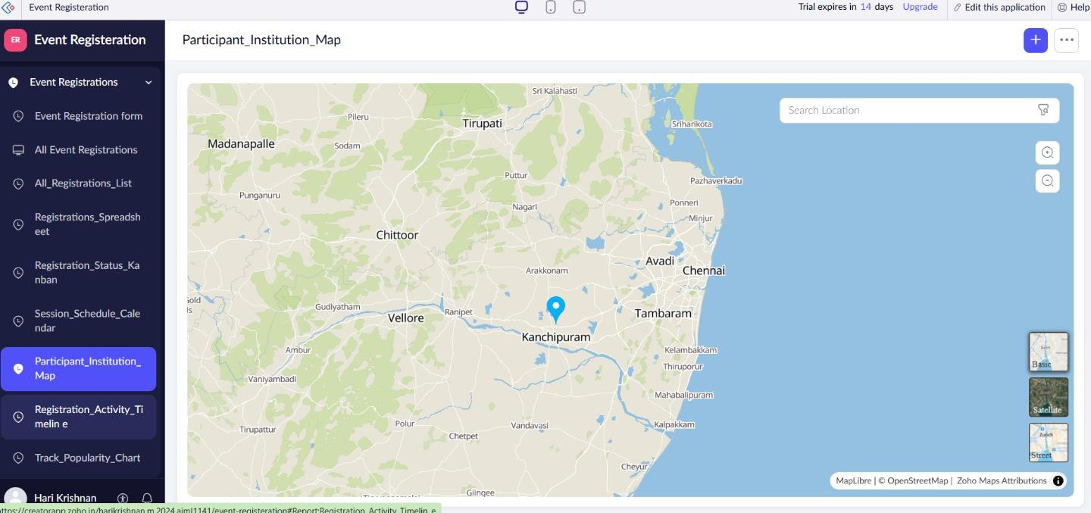

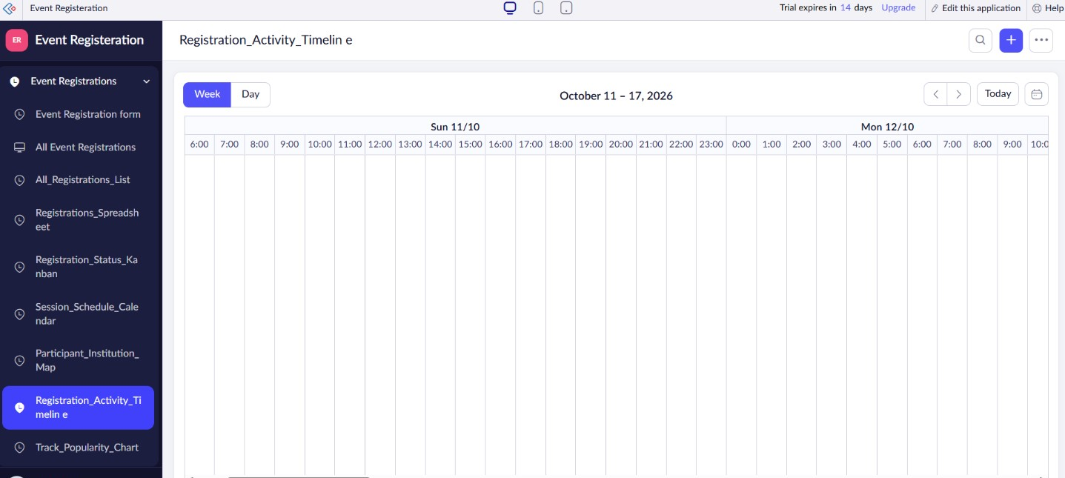

Result:
A suite of nine Zoho Creator reports for the Event Registration Form application has been designed and documented.

